Ideation Phase
Empathy Map Canvas Template

Date | 10-02-2026
Team ID | LTVIP2026TMIDS65437
Project Name | Flavour Fusion: - Ai-Driven Recipe Blogging
Maximum Marks | 4 Marks

Empathy Map:
An empathy map is a simple, easy-to-digest visual that captures knowledge about a user’s behaviours and attitudes.

It is a useful tool to help teams better understand their users.
Creating an effective solution requires understanding the true problem and the person who is experiencing it. The exercise of creating the map helps participants consider things from the user’s perspective along with his or her goals and challenges.

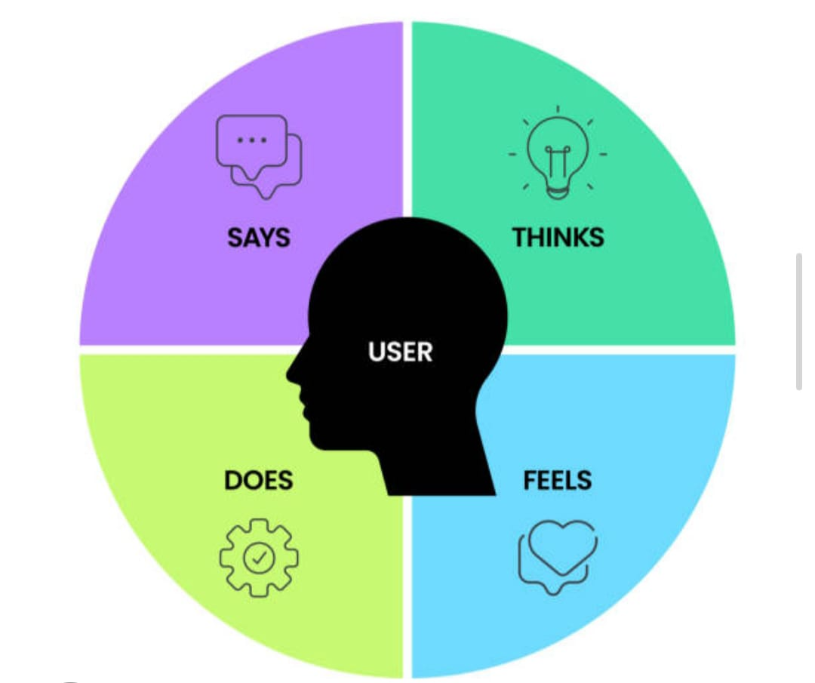

Empathy Map Example:
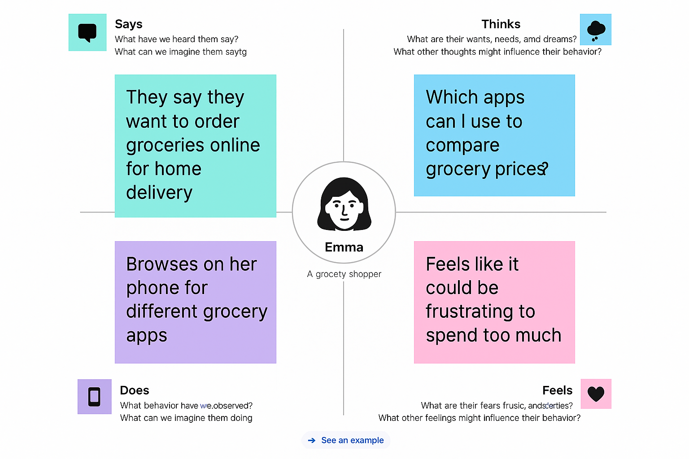

THINKS & FEELS
"I want to cook something exciting, but I'm tired after work."
"I have random ingredients in the fridge—how can I combine them?"
SAYS
“I wish I could take a photo of this dish and get the recipe."
"I need a quick, healthy meal idea right now."
DOES
“Takes photos of food in restaurants for inspiration”.
“Searches YouTube/blogs for quick recipes.”

SEES & HEAR OR FEELS
“Sees: Highly curated food photography on Instagram.”

Empathy Map Canvas Template:
An Empathy Map Canvas for a "Flavours Fusion AI-Driven Recipe Blogging" project is a visual tool used to understand the emotional, cognitive, and behavioral needs of users who want to create, discover, or blog about innovative, combined-cuisine recipes. It helps the project team move beyond just "making a recipe app" to creating a user-centric, AI-driven experience that solves real cooking pain points.

